JavaScript and Graphics by ________________________
// 3.5.3 This program will add text that
// says "Hello world" at 100, 100.
function start(){
var text = new Text("Hello world");
text.setPosition(100, 100);
add(text);
// add code to say Goodbye at the bottom of the screen

}
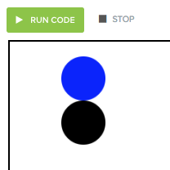
// 3.5.4 This program will add a blue circle
// with radius 30 and center at (100,50).
function start(){
var circle = new Circle(30);
circle.setPosition(100, 50);
circle.setColor(Color.blue);
add(circle);
// add another circle, the same size touching below

}
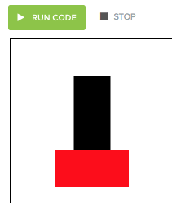

// 3.5.5 This program will add a red rectangle
// with width 100 and height 50 at position
// (60, 150).
function start(){
var rect = new Rectangle(100, 50);
rect.setPosition(60, 150);
rect.setColor(Color.red);
add(rect);
// add another rectangle that is 50 wide and 100 tall sitting on top of the first rectangle.

/* 3.5.7 This program should draw the French flag. The
* left third of the canvas is blue, the middle third
* is white, and the right third is red. */
function start(){

/* 3.5.8 Design a snowman. Add an extra feature like a hat or carrot nose.
* Constants representing the radius of the top, middle,
* and bottom snowball. */
var BOTTOM_RADIUS = 100;
var MID_RADIUS = 60;
var TOP_RADIUS = 30;

function start(){
/* Write your code to make the snowman here! */

